**Involuntary Railway Gate System**

Table of Contents

**About Involuntary railway gate system** 1

Abstract 2

Identifying Features 1

SWOT Analysis 1

5W's and 1H 1

**Requirements** 2

High Level Requirements 2

Low Level Requirements 2

**Architecture** 3

Block Diagram 3

Behaviour Diagram 4

• Flow Chart 4

Structural Diagram 5

• Use Case 5

**Applications** 6

**Test Case** 6

**Results** 6

**About Involuntary railway gate system**

Abstract

The project Involuntary Railway Gate System attempts to automate the opening and closing of gates at a railway level crossing. With the help of this the human intervention can be avoided by automating the process and also many railway level crossing accidents can be prevented. It includes IR Sensor, Micro Controller, LCD, motor and buzzer/LED.

Identifying Features

* An IR sensor is used to sense the arrival and departure of the train
* The gate automatically opens and close upon the arrival and departure of the train
* LCD displays the information about the arrival & departure of train
* When the train arrives, buzzer sounds to alter the people/vehicle

SWOT Analysis

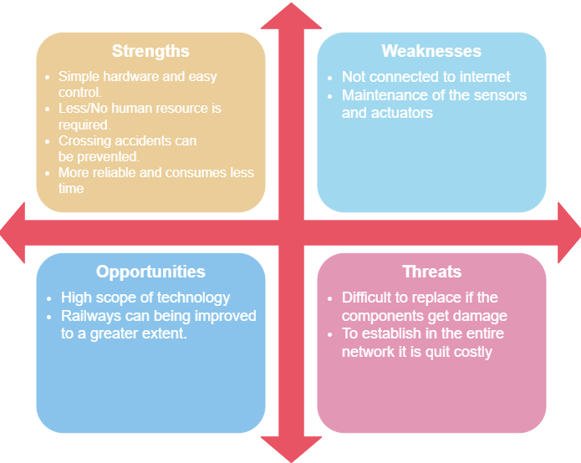

5W's and 1H

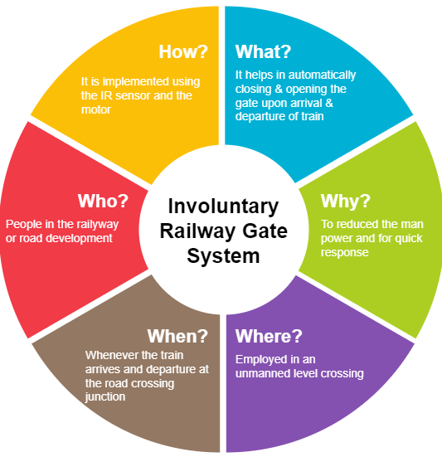

**Requirements**

High Level Requirements

|  |  |  |
| --- | --- | --- |
| **ID** | **Description** | **Status** |
| HLR1 | It shall open the gate on the arrival of train | Implemented |
| HLR2 | It shall close the gate on the departure of train | Implemented |
| HLR3 | It shall display the information about arrival & departure of train | Implemented |
| HLR4 | It shall alter through buzzer/LED when train comes | Implemented |

Low Level Requirements

|  |  |  |  |
| --- | --- | --- | --- |
| **ID** | **Description** | **HLR ID** | **Status** |
| LLR1 | IR sensor detects the arrival and departure of the train | HLR1 & HLR2 | Implemented |
| LLR2 | The motors rotate clockwise to open the gate | HLR1 | Implemented |
| LLR3 | The motors rotate anti clockwise to close the gate | HLR2 | Implemented |
| LLR4 | The ADC convert the analog value to digital value to display | HLR3 | Implemented |
| LLR5 | The micro controller should activate buzzer/LED | HLR4 | Implemented |

**Architecture**

Block Diagram

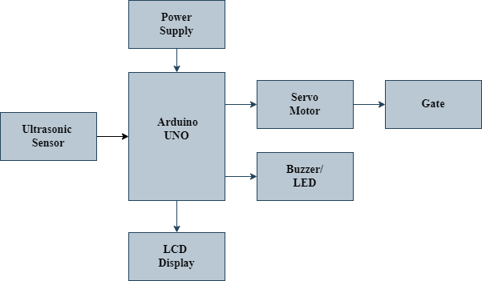

The Involuntary Railway Gate System is a simple embedded system which automatically opens and closes the gate at a railway level crossing. It includes IR Sensor, ARM Controller, stepper motor, LCD display and buzzer/LED.

* Ultrasonic Sensor

 The ultrasonic sensor is used to sense the arrival and departure of the train. It works on the "echolocation" principle. The device generates a wave or pulse from the sensor trig pin, and the pulses return to the sensor after hitting an obstacle to the echo pin of the sensor. Thich transmits the digital (0,1) signal, if the object is detected.

* Arduino UNO

The Arduino Uno is a microcontroller board based on the ATmega coupled with an integrated development environment (IDE) for creating logic on the chip. The controller helps in opening and closing the gate when the train passes at the junction. All the sensor and actuator are interfaced with the controller unit. When the ultrasonic sensor detects the arrival of the train, the controller starts the motor in order to close the gate. And similarly, when the train departs, the controller starts the motor to open the gate. It also sends information to LCD BUZZER and LED for display purposes.

* Servo Motor

The servo motor is an electromechanical device. It has three wires out of which two will be used for supply (i.e., positive and negative) and one will be used for the signal that is to be sent from the MCU. PWM (Pulse width Modulation) is used to control the servo motor, which is provided by the control wires. There is a minimum pulse, a maximum pulse and a repetition rate. From its neutral position, the servo motor can turn 90 degrees in either direction. Servo motors can be rotated from 0 to 180 degrees depending on the manufacturing.

* LCD Display

The LCD display is a type of flat panel display which uses liquid crystals in its primary form of operation. With the help of digital data from the ADC the data will be displayed on the LCD that is when the train reaches the junction it displays as "The train had arrived" and similarly it displays "The train left the junction" when its departures.

* Buzzer/LED

The buzzer/LED is interfaced with the controller in order to alter the people and vehicle present at the junction on the arrival and departure of the train.

Behavioral Diagram

* Flow Chart

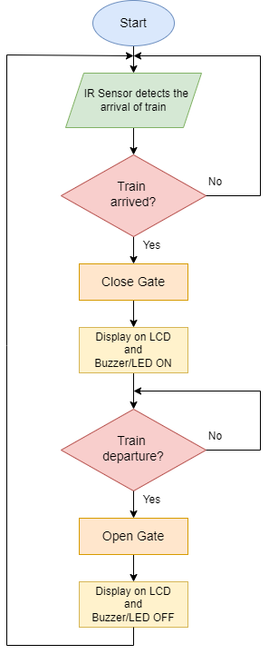

Structural Diagram

* Use Case

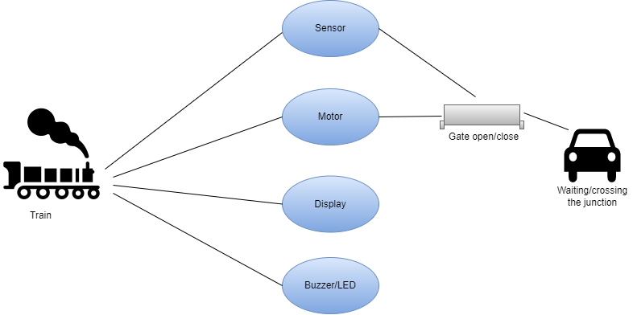

**Applications**

* Real time transport systems
* Railway gate control.
* Parking gate control.

**Test Case**

|  |  |  |  |  |
| --- | --- | --- | --- | --- |
| Test ID | Test case Objective | Input data | Excepted data | Actual Output |
| TC_01 | Arrival of the Train | Detecting train from the sensor (Value from potentiometer) | Closes the gate  Buzzer & LED ON  Displays on LCD | Closes the gate  Buzzer & LED ON  Displays on LCD |
| TC_02 | Departure of the train | Detecting train from the sensor (Value from potentiometer) | Opens the gate  Buzzer & LED OFF  Displays on LCD | Opens the gate  Buzzer & LED OFF  Displays on LCD |

**Results**

* When the train arrives: Buzzer and LED turns ON. And also displays on the LCD informing the roadside vehicle or people to wait until the departure.

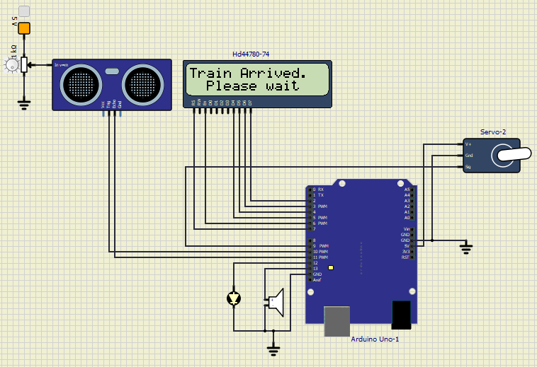

* When the train departs: Buzzer and LED turns OFF. And also displays on the LCD informing that the vehicles or people can move.

